University of Pittsburgh
History of Art and Architecture

Foreign Language Questionnaire

The Foreign Language Questionnaire is a required component of the application packet. Applicants must submit this completed form and all other materials to the department by December 15th.
Prior to admission, students in the East Asian program must have at least three years/six semesters of college-level Japanese or Chinese, with a grade of B+ or better, or equivalent knowledge.
Prior to admission, students working in Western languages must have at least two years/four semesters of college-level instruction, with a grade of B+ or better, of a major research language, or equivalent knowledge. Questions about language preparation should be addressed to the faculty member with whom the prospective student would like to work.
In order to demonstrate progress towards the PhD degree, graduate students are required to have reading knowledge of two foreign languages relevant to their particular field of study. The relevance of these languages to the student’s course of study will be determined upon admission and in consultation with the academic advisor. All enrolled students must pass departmental exams in their two research languages, and only native speakers will be exempted. Language exams will be given once at the beginning of each term and will be administered by a Faculty Exam Coordinator, serving in rotation according to area of expertise.
This questionnaire serves as a preliminary self-evaluation of prospective students foreign language skills. It has two parts—language assessment and translation. Applicants are expected to complete the form honestly and follow these guidelines:
- The translation should reveal the applicant’s current skill level. Faculty evaluators will place a greater emphasis on overall understanding and familiarity with art historical terminology than a literal translation.
- Applicants may use a language to language dictionary, but the use of online translators is prohibited. The translation must be the applicant’s own work.
- It is possible that an applicant may have skills in a language not included in the translation part of this questionnaire. In that case, the applicant should provide a paragraph (in English) explaining their background and experience with the language.

Any questions should be directed to the Graduate Administrator (Corrin Trombley cot12@pitt.edu, 412-648-2400).

The University of Pittsburgh is an affirmative action, equal opportunity institution.
Name: ________________________________________________________________

Native Language(s): ____________________________________________________

Assess your foreign language skills. You may list more than one foreign language. If you would like to include more information, you may attach a sheet to this document.

Language _________________________
Years of study in high school _____
Semesters of study at college or university level and grades ________________ ________________________________________________________________
Other relevant experience (study, living abroad) __________________________ ________________________________________________________________

Estimate of your skill:
Reading: __ Excellent __ Good __ Fair __ Poor
Speaking: __ Excellent __ Good __ Fair __ Poor
Writing: __ Excellent __ Good __ Fair __ Poor

Language _________________________
Years of study in high school _____
Semesters of study at college or university level and grades ________________ ________________________________________________________________
Other relevant experience (study, living abroad) __________________________ ________________________________________________________________

Estimate of your skill:
Reading: __ Excellent __ Good __ Fair __ Poor
Speaking: __ Excellent __ Good __ Fair __ Poor
Writing: __ Excellent __ Good __ Fair __ Poor

Language _________________________
Years of study in high school _____
Semesters of study at college or university level and grades ________________ ________________________________________________________________
Other relevant experience (study, living abroad) __________________________ ________________________________________________________________

Estimate of your skill:
Reading: __ Excellent __ Good __ Fair __ Poor
Speaking: __ Excellent __ Good __ Fair __ Poor
Writing: __ Excellent __ Good __ Fair __ Poor

Translate according to your ability (see page 1 for guidelines). If you have any technical difficulties with characters contact Molly Sabol.

GERMAN

Das Auffallendste älteren Gemälden gegenüber dürfte in der Komposition das Vermeiden der räumlichen Vertiefung der Darstellung sein. Bei jedem der Bilder in Sta. Maria Maggiore versuchte der Maler eine räumliche Vertiefung nicht nur durch die Darstellung einer Landschaft oder eines Innenraumes, sondern auch durch perspektivische Verteilung der Figuren in dem dargestellten Raumausschnitte zu erzielen. Auch in dem Apsisgemälde in SS. Cosma e Damiano konnen wir dieses Bestreben noch beobachten, da die Figuren auf verschiedenen Plänen einer wenn auch schmalen landschaftlichen Szenerie untergebracht sind und Christus in perspektivischer Verkürzung über der Landschaft und im vertieften Hintergrunde, gleichsam wie über dem Horizont auf Wolken schwebend, dargestellt ist.
____________________________________________________________________________________________________________________________________________
____________________________________________________________________________________________________________________________________________
____________________________________________________________________________________________________________________________________________
____________________________________________________________________________________________________________________________________________
____________________________________________________________________________________________________________________________________________
____________________________________________________________________________________________________________________________________________
______________________________________________________________________

FRENCH

Le catalogue de la Vente Crozat en 1741, est une étape essentielle dans la carriére du connaisseur. Le seul fait que Mariette ait été choisi pour l'établir montre qu'il s'était deja, à cette date, imposé par l'étendue de ses connaissances et la clairvoyance de ses avis; auparavant, il avait «ordonné» la collection d'estampes du Prince Eugène de Savoie (n° 297 de la présente exposition) et dressé un Bref état des richesses du fonds royal de gravures (n° 334). Pour les dessins de Crozat, la tâche était lourde: pres de 19 000 pieces à répertorier, à grouper par Ecoles, par artistes ou par tendances. «Ce catalogue, écrira Dumesnil, le premier en France qui soit sorti de l’ornière d'une sèche nomenclature, fit une grande sensation parmi les amateurs et les artistes»
____________________________________________________________________________________________________________________________________________
____________________________________________________________________________________________________________________________________________
____________________________________________________________________________________________________________________________________________
____________________________________________________________________________________________________________________________________________
____________________________________________________________________________________________________________________________________________
____________________________________________________________________________________________________________________________________________

ITALIAN

Queste preferenze classicheggianti agevolano in qualche modo la reazione al Gotico di Filippo Brunelleschi, uomo dei nuovi tempi, nei quali si va formando l'individualismo umanistico. Il Brunelleschi si forma studiando profondamente a Roma le vestigia antiche (prima con Donatello, poi da solo), ma non è solo un esteta umanista, è un tecnico di mirabile compiutezza e inventiva, che risolve fino all'ultimo dettaglio l'arduo problema di voltare la cupola gigantesca di S. Maria del Fiore; ed egli dà per nuovo fondamento alle arti figurative la prospettiva, che comporta anche chiari rapporti geometrici tra le forme.
____________________________________________________________________________________________________________________________________________
____________________________________________________________________________________________________________________________________________
____________________________________________________________________________________________________________________________________________
____________________________________________________________________________________________________________________________________________
____________________________________________________________________________________________________________________________________________
____________________________________________________________________________________________________________________________________________

SPANISH

De esta guisa, las fuentes de las que se sirvió Velázquez para dar cierta verosimilitud ambiental a la composición se remiten todas al momento en que tuvo lugar la victoria y no a lo que estaba
ocurriendo realmente en el momento en que se pintó. Entre dichas fuentes, se cita el libro del jesuita Herman Hugo, Obsidio Bredana, donde, con gran aparato de mapas y planos del lugar, se describe
minuciosamente la campaña. Velázquez se sirvió obviamente de esta información cartográfica para lograr dar verosimilitud al soberbio paisaje de fondo que luego se muestra en el cuadro. También
debió de conocer los grabados de Jacques Callot pero la calidad del cuadro no depende de otras documentaciones gráficas empleadas por el pintor. Basta con comparar Las lanzas con las tres versiones de este mismo asunto que ilevó a cabo Peter Snayers, cuyo interés se agota en lo meramente topográfico. De hecho, uno de los principales aciertos de Velázquez consistió en transformar un típico
cuadro de batallas, en el que la información topográfica era lo esencial, en un cuadro de historia en el más alto sentido albertiano.
_______________________________________________________________________________________________________________________________________
____________________________________________________________________________________________________________________________________________
____________________________________________________________________________________________________________________________________________
____________________________________________________________________________________________________________________________________________
____________________________________________________________________________________________________________________________________________
____________________________________________________________________________________________________________________________________________

CLASSICAL LATIN

Tabulis externis externis auctoritatem Romae publice fecit primus omnium L.
Mummius cui cognomen Achaici victoria dedit. namque cum in praeda vendenda rex Attalus 600,000 emisset tabulam Aristidis, Liberum patrem, pretium miratus suspicatusque aliquid in ea virtutis quod ipse nesciret, revocavit tabulam Attalo multum querente et in Cereris delubro posuit, quam primam arbitror picturam externam Romae publicatam.
____________________________________________________________________________________________________________________________________________
____________________________________________________________________________________________________________________________________________
____________________________________________________________________________________________________________________________________________
____________________________________________________________________________________________________________________________________________

MEDIEVAL LATIN INSCRIPTIONS

Omnia dispono solus / Meritosque corono / Quos scelus exercet / Me judice poena coercet. Quisque Resurget ita / Quem non Trahit impia vita / Et lucebit ei / sine fine lucerna diei. Terreat hic terror / Nam fore sic verum / Quos terreus alligat error / Notat his horror specierum.
____________________________________________________________________________________________________________________________________________
__________________________________________________________________________________________________________________________________________________________________________________________________________________

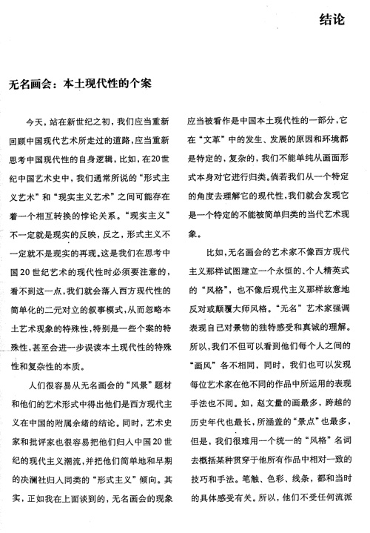
MODERN CHINESE

________________________________
________________________________
________________________________
________________________________
________________________________
________________________________
________________________________
________________________________
________________________________
________________________________
________________________________
________________________________
________________________________
________________________________
________________________________
________________________________
________________________________
________________________________
________________________________
________________________________
________________________________
________________________________
________________________________
________________________________
________________________________
________________________________
________________________________
________________________________
________________________________
________________________________
________________________________
________________________________
________________________________
________________________________
________________________________
________________________________

JAPANESE

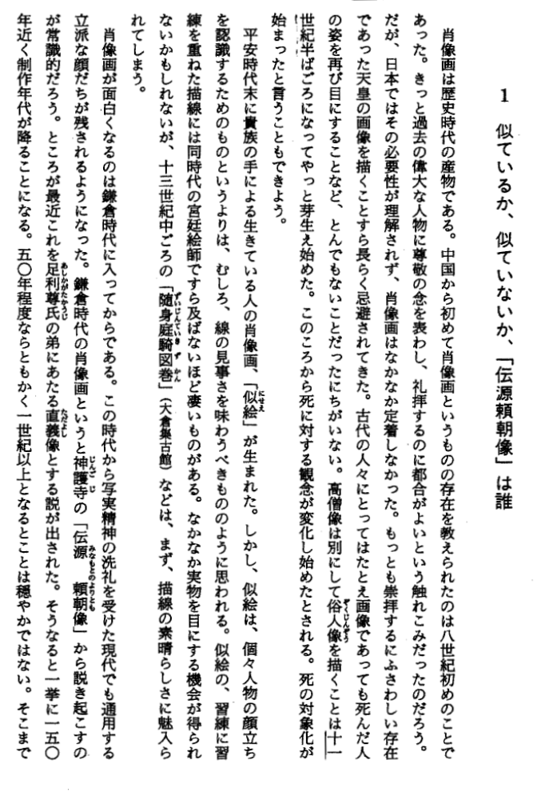

____________________________
____________________________
____________________________
____________________________
____________________________
____________________________
____________________________
____________________________
____________________________
____________________________
____________________________
____________________________
____________________________
____________________________
____________________________
____________________________
____________________________
____________________________
____________________________
____________________________
____________________________
____________________________
____________________________
____________________________
____________________________
____________________________
____________________________
____________________________
____________________________
____________________________
____________________________
____________________________
____________________________
____________________________
____________________________
____________________________
____________________________

If you have experience in a language not listed for translation, please attach a paragraph (English) detailing your background and knowledge.

